World Trade
Organization
World Trade  Organization | WT/REG228/1/Rev.1  1 October 2008
 | (08-4622)
Committee on Regional Trade Agreements

FACTUAL PRESENTATION

Comprehensive Economic Cooperation Agreement
Between
India and Singapore
(Goods and Services)

Report By the Secretariat

Revision

This report, prepared for the consideration of the Comprehensive Economic Cooperation Agreement between India and Singapore has been drawn up by the WTO Secretariat on its own responsibility and in full consultation with the Parties. The report has been drawn up in accordance with the rules and procedures contained in the Decision for a Transparency Mechanism for Regional Trade Agreements (document WT/L/671).

Any technical questions arising from this report may be addressed to Ms. Jo-Ann Crawford (tel: +41 22/739 5422) and Mr. Dale Honeck (tel: +41 22/739 5149).

TABLE OF CONTENTS

Page

I. trade environment 1
A. Merchandise Trade 1
B. Trade In Services And Investment 4
II. TREATY CHARACTERISTIC ELEMENTS 6
A. Background Information 6
III. National treatment and market access for goods 7
1. Import duties and charges, and quantitative restrictions 7
2. Rules of origin 12
3. Export duties and charges, and quantitative restrictions 13
A. Regulatory Provisions Of The Agreement 13
1. Standards 13
2. Safeguard mechanisms 14
3. Anti-dumping 15
4. Subsidies, state-aid and countervailing measures 15
5. Other regulations 15
IV. Provisions on Trade in Services and Investment 15
A. Scope And Definitions 15
B. Denial Of Benefits 16
C. Market Access 16
D. National Treatment, Mfn, Standard Of Treatment 16
E. Movement Of Natural Persons 17
F. Investment 17
G. Domestic Regulation 17
H. Mutual Recognition 17
I. Liberalization Commitments 18
1. Singapore 19
2. India 20
J. Safeguard Actions On Services Trade And Investment 21
V. provisions affecting trade in goods, services and investment 22
A. E-Commerce 22
B. Intellectual Property 22
C. Government Procurement 22
D. Sector-Specific Provisions Of The Agreement 22
E. Institutional Provisions Of The Agreement 22
1. Exceptions and reservations 22
2. Accession 23
3. Institutional framework 23
4. Dispute settlement 23
5. Relationship with other agreements concluded by the Parties 24
ANNEX 25

COMPREHENSIVE ECONOMIC COOPERATION AGREEMENT BETWEEN
INDIA AND SINGAPORE (GOODS & SERVICES)

Factual Presentation by the Secretariat

trade environment

Merchandise Trade
          - The Comprehensive Economic Cooperation Agreement between India and Singapore (hereafter "the Agreement") is Singapore's second bilateral free trade agreement (FTA) with an Asian country. It is India's first FTA covering services. Of the Parties, India ranked as the world's 29th top exporter and 17th top importer in 2005 in terms of merchandise trade, while for the same year Singapore was the world's 14th largest exporter and 15th largest importer. In the period 2003-2005, India's trade to GDP ratio was 36.6, while Singapore's ratio was 431.8.
          - Developments in recent years in global and intra trade between the Parties are pictured in Charts I.1 and I.2. Over the period surveyed (1997-2005), trade between the Parties has fluctuated. For the latest period surveyed (2003-2005), India's figures show a growing trade surplus with Singapore, while Singapore's figures for the period 1997-2005 show a consistent trade surplus in its favour.
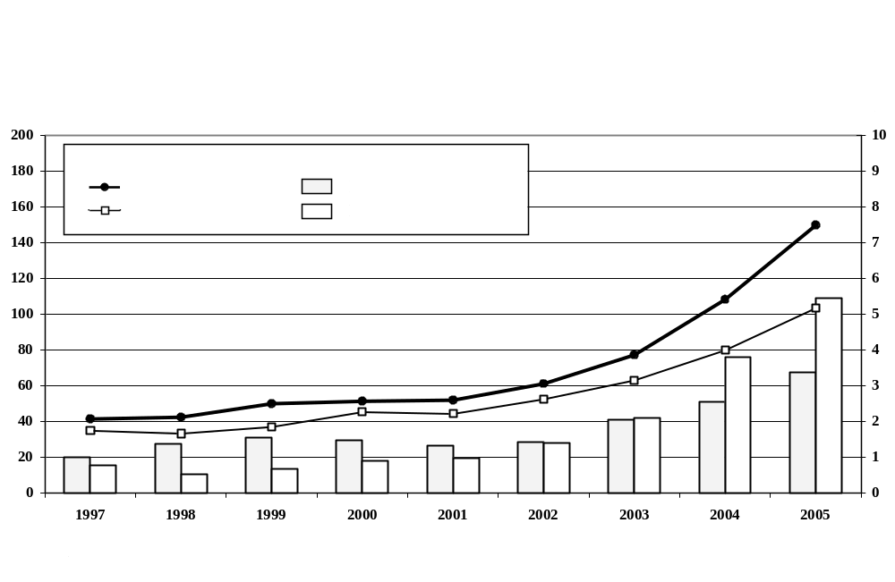

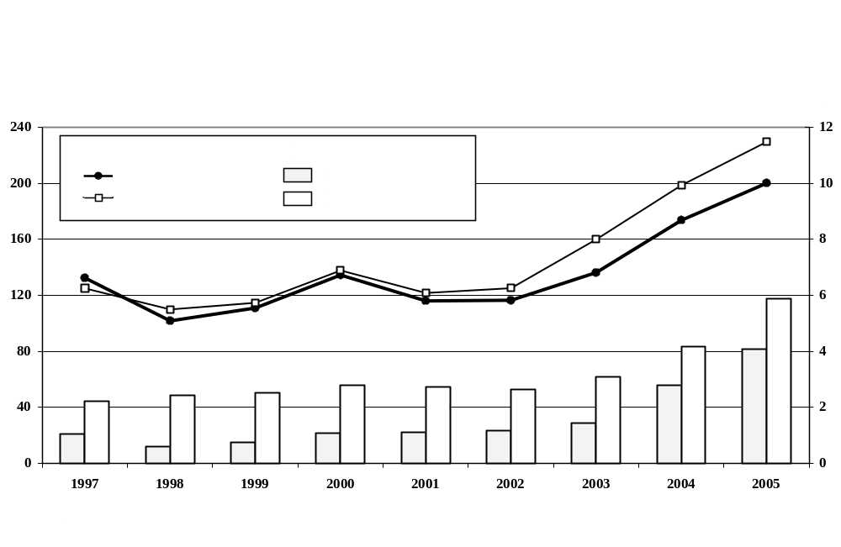

          - The commodity structure of trade among the Parties, as well as of their imports and exports to the world in the period 2003-2005, is shown in Chart I.3, on the basis of Harmonized System (HS) sections.
          - Three product categories (machinery, chemicals and vehicles) accounted for more than 75% of India's imports from Singapore; wood pulp and base metals accounted for a further 12.6%. Singapore's three largest export product categories – machinery, minerals and chemicals – made up 79.1% of its total exports in 2003-2005 and accounted for 64.5% of India's imports from Singapore in 2003-2005.
          - As to Singapore's imports from India in the period 2003-2005, more than 80% were classified under four product categories (minerals, pearls, base metals and chemicals). India's four largest export product categories – textiles, pearls, minerals and chemicals – made up 58.6% of its total exports in 2003-2005 and accounted for 75.9% of Singapore's imports from India in 2003-2005.

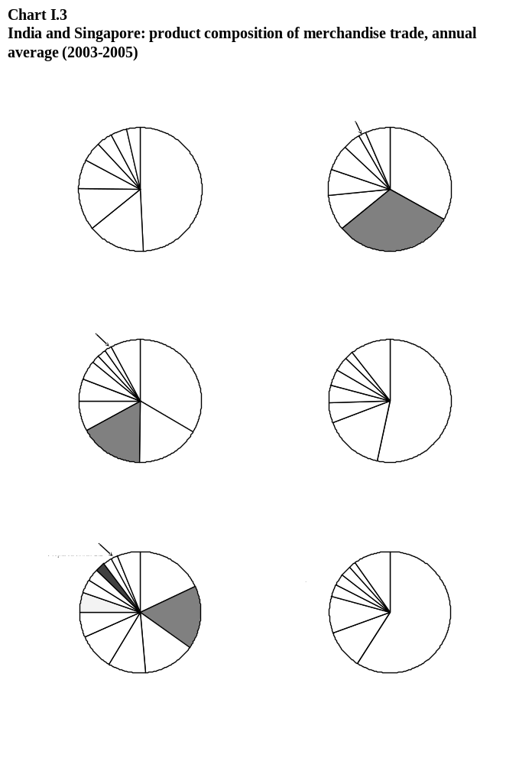

Trade In Services And Investment
          - In 2005, India ranked 15th in the world in terms of imports of commercial services, and 12th in terms of exports. India's commercial services imports amounted to US$49.5 billion in 2005, representing 2.1% of world imports, while exports amounted to US$54.4 billion, representing 2.2% of world exports. In the same year, Singapore ranked 13th in the world in terms of imports of commercial services and 16th in terms of exports. Singapore's commercial services imports amounted to US$54.1 billion in 2005, representing 2.3% of world imports, while exports amounted to US$51.2 billion, representing 2.1% of world exports.
          - Chart I.4 shows the breakdown of commercial services trade for India in 1997-2003 (the most recent available). Since 2000, computer and information services have accounted for a growing share of India's commercial services exports, while transportation services and other business services account for the largest shares of imports.
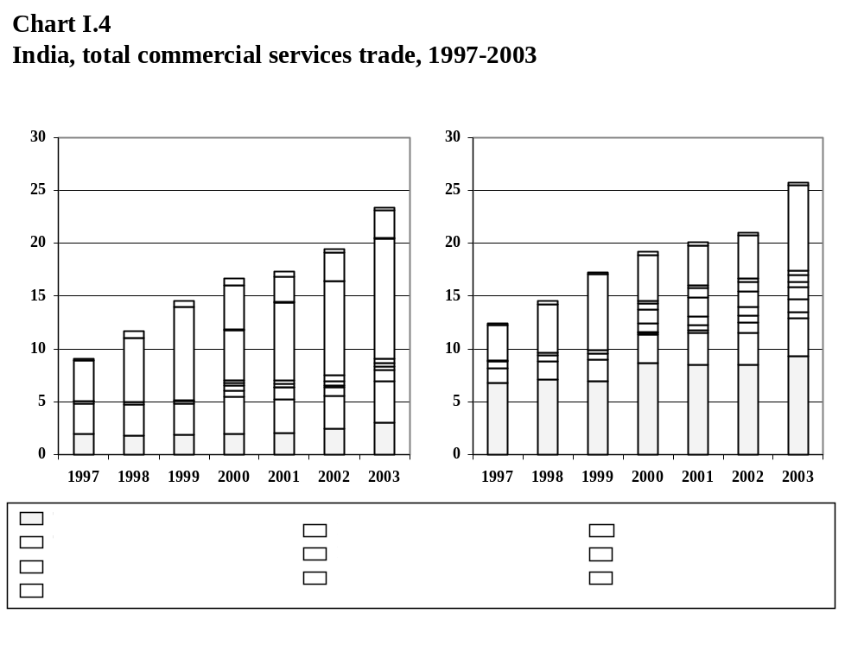

          - Chart I.5 shows the breakdown of commercial services trade for Singapore in the years 2000-2005. Transportation services and other business services account for the largest share of Singapore's commercial services exports, while transportation and travel services, royalties and license fees and other business services account for the largest shares of imports.

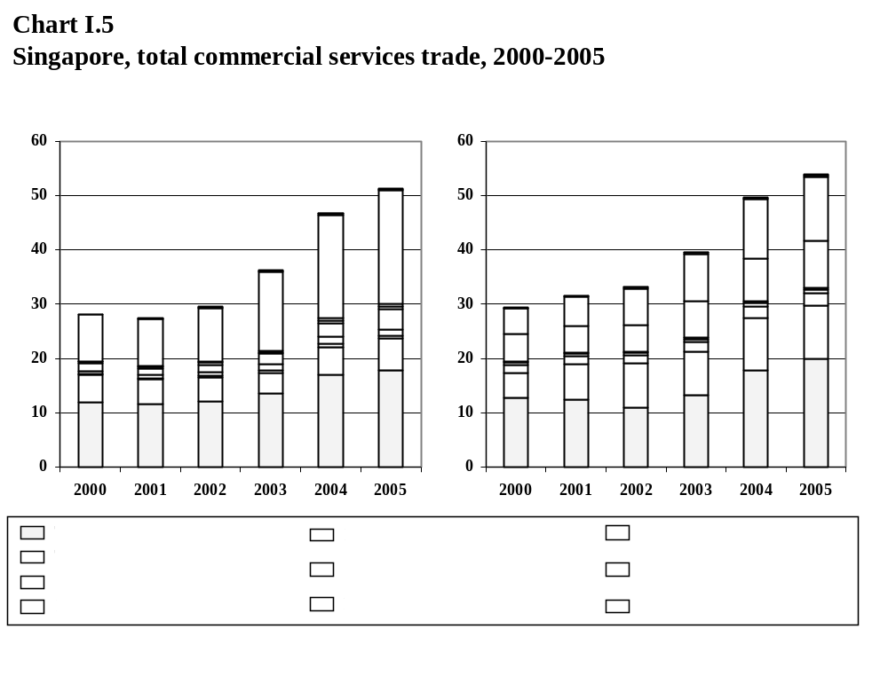
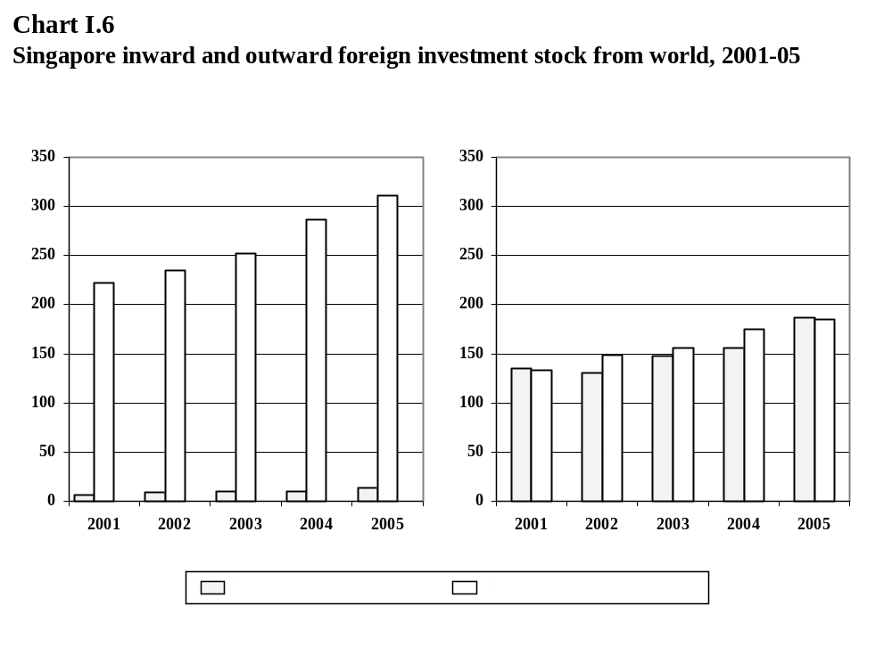
          - Singapore's global investment position is depicted in Chart I.6. Singapore's inward stock of foreign direct investment increased 44% over the period 2001-2005, while its stock of outward foreign direct investment increased by 39% over the same period.
          - Singapore's investment position with India is depicted in Chart I.7 which shows Singapore's inward and outward stock of foreign direct investment with India over the period 2001-2005. Singapore's foreign direct investment in India accounted for 1.9% of its total outward foreign direct investment in 2005, up from 1.5% the previous year. Singapore accounts for a small, but growing percentage of inward foreign investment from India. In 2005, foreign direct investment in Singapore by India represented 1.7% of total FDI in Singapore by Asian investors, up from 0.7% in 2004.
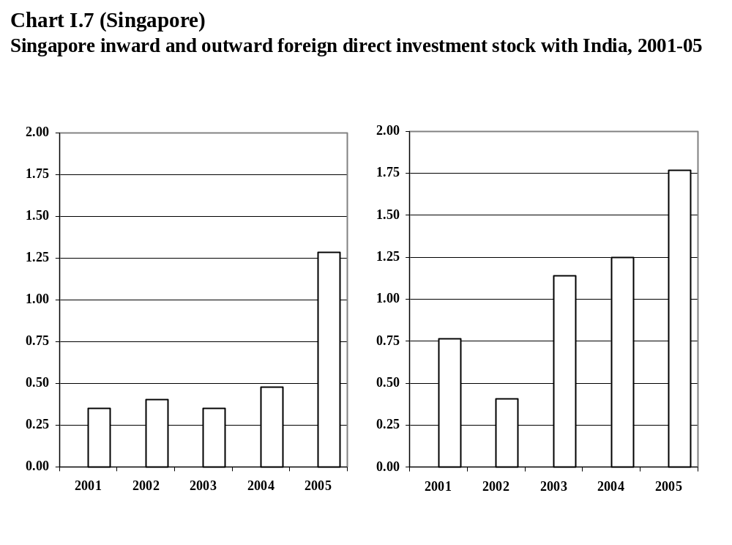

TREATY CHARACTERISTIC ELEMENTS

Background Information
          - The Comprehensive Economic Cooperation Agreement was signed by the Government of India and the Government of Singapore on 29 June 2005 and entered into force on 1 August 2005. The Agreement is of an indefinite duration.
          - The Agreement was notified to the WTO by the Parties on 3 May 2007 under Article XXIV:7(a) of the GATT 1994 and Article V:7(a) of the GATS (WT/REG228/N/1). The text is available, together with its Annexes, on the Parties' official websites.

          - The Agreement is composed of 16 Chapters, as follows:
Box II.1: Table of contents of the Agreement
Chapter 0 Preamble
Chapter 1 Objectives and General Definitions
Chapter 2 Trade in Goods
Chapter 3 Rules of Origin
Chapter 4 Customs
Chapter 5 Standards
Chapter 6 Investment
Chapter 7 Services
Chapter 8 Air services
Chapter 9 Movement of Natural Persons
Chapter 10 E-commerce
Chapter 11 Intellectual Property Cooperation
Chapter 12 Science and Technology
Chapter 13 Education
Chapter 14 Media
Chapter 15 Dispute Settlement
Chapter 16 General and Final Provisions

          - The Agreement contains fifteen annexes which deal inter alia with: investment concessions; services concessions; sectoral concessions on telecommunication equipment, food products and electronic products; financial services; telecommunications services; list of professionals; and a framework for media cooperation.
          - The Agreement contains no explicit transition period: in the case of Singapore, tariff elimination on imports of goods from India takes place on the date of entry into force of the Agreement; in the case of India tariff reductions or eliminations are to be completed within a period of four years, i.e. by 1 April 2009. The commitments made by the Parties on trade in services are effective upon entry into force of the Agreement, unless otherwise specified in their schedules of commitments.

National treatment and market access for goods

Import duties and charges, and quantitative restrictions

General provisions
          - The Parties agree to accord national treatment to the goods of the other party in accordance with Article III of the GATT 1994 (Article 2.2 of the Agreement).
          - Market access provisions for the reduction and/or elimination of customs duties are addressed in Annexes 2A and 2B, for India and Singapore, respectively. Tariff liberalization covers Chapters 1-97 of the Harmonized System (HS). In the case of India, the Agreement provides for the elimination of duties on imports of certain goods originating in Singapore on the date of entry into force. A second list contains products that are subject to a phased elimination of duty in five annual stages while for a third list duties are progressively reduced over a five year period, but not eliminated. A fourth list contains those products not subject to concessions. In the case of Singapore, customs duties on all products originating in India are eliminated on the date of entry into force of the Agreement.
          - Article 2.5 prohibits the Parties from adopting or maintaining any non-tariff measures on imports or exports, except in accordance with its WTO rights and obligations or in accordance with other provisions of the Agreement.
          - In accordance with Article 2.3.2, upon request the Parties agree to consult each other to consider the possibility of accelerating the reduction and/or elimination of customs duties. Article 2.11 provides that if a Party concludes a preferential agreement with a third party, following the signature of this Agreement, it will give the other Party the opportunity to negotiate for the more favourable concessions and benefits granted therein.
          - The Parties agree to allow duty-free temporary admission for certain goods detailed in Article 2.15, subject to the conditions therein.

Liberalization of tariff lines and trade
          - The elimination of tariffs applicable between the Parties is detailed in the corresponding Parties' schedules. In the case of India, tariff elimination and/or reduction began on 1 August 2005, using the MFN rate in force on that date. Subsequent reductions of duty take place on 1 April of the given year.
          - The overall tariff elimination under the Agreement is depicted in Tables III.1A and III.1B below. In the case of India, 2.7% of total tariff lines were already duty-free on an MFN basis in 2006. A further 2.2% of tariff lines became duty-free for imports from Singapore in 2006; in terms of imports from Singapore for the period 2003-2005, these figures amount to 38.1 and 10.1%, respectively. By the end of the transition period in 2009, a further 18.9% of tariff lines are to be liberalized, accounting for 26.9% in terms of imports from Singapore for the period 2003-2005. Thus, a total of 23.6% of tariff lines are liberalized under the Agreement, corresponding to 75.1% in terms of import values from Singapore for the period 2003-2005.
Table III.1A
Tariff elimination commitments under the Agreement and corresponding average trade values for 2003-05*
A: India
Duty phase-out period | Number  of lines | % of total lines in India's Tariff Schedule | Value of India's imports from Singapore  (US$ million) | % of India's total imports from Singapore
MFN duty free | 313 | 2.7 | 1,024.4 | 38.1
2006 | 252 | 2.2 | 271.7 | 10.1
2009 | 2,178 | 18.7 | 722.8 | 26.9
Remain dutiable | 8,886 | 76.4 | 665.0 | 24.7
Total | 11,629 | 100.0 | 2,691.5 | 100.0
* India's tariff schedule and import values are valid for a fiscal year, i.e. from 1 April to 31 March.

          - In the case of Singapore, 99.9% of tariff lines were already duty-free on an MFN basis in 2006. All remaining tariff lines were liberalized as of the entry into force of the Agreement, resulting in a liberalization of 100 percent of trade and tariff lines.
Table III.1B
Tariff elimination commitments under the Agreement and corresponding average trade values for 2003-05
B: Singapore
Duty phase-out period | Number  of Lines | % of total lines in Singapore's Tariff Schedule | Value of Singapore's imports from India (US$ million) | % of Singapore's total imports from India
MFN duty free | 10,682 | 99.9 | 4,648.5 | 99.6
2006 | 6 | 0.1 | 1.4 | 0.0*
Total | 10,688 | 100.0 | 4,666.4 | 100.0
* Imports from India of the value of US$16.6 million in HS Chapters 98-99 are not classified in the Harmonized System.
Source: WTO Secretariat estimates, based on data provided by India and Singapore authorities.

India's liberalization schedule
          - The base rates used by India for implementing its tariff liberalization scheme already provided for 2.7% of tariff lines being duty free before the entry into force of the Agreement. As can be seen from Chart III.1, most of the additional 2.2% of tariff lines freed upon entry into force held base rates of 20% or less. Further reductions of duties take place in 2007 and 2008, but no elimination takes place. In 2009, most of the 18.7% of tariff lines liberalized have a base rate of 20% or less.

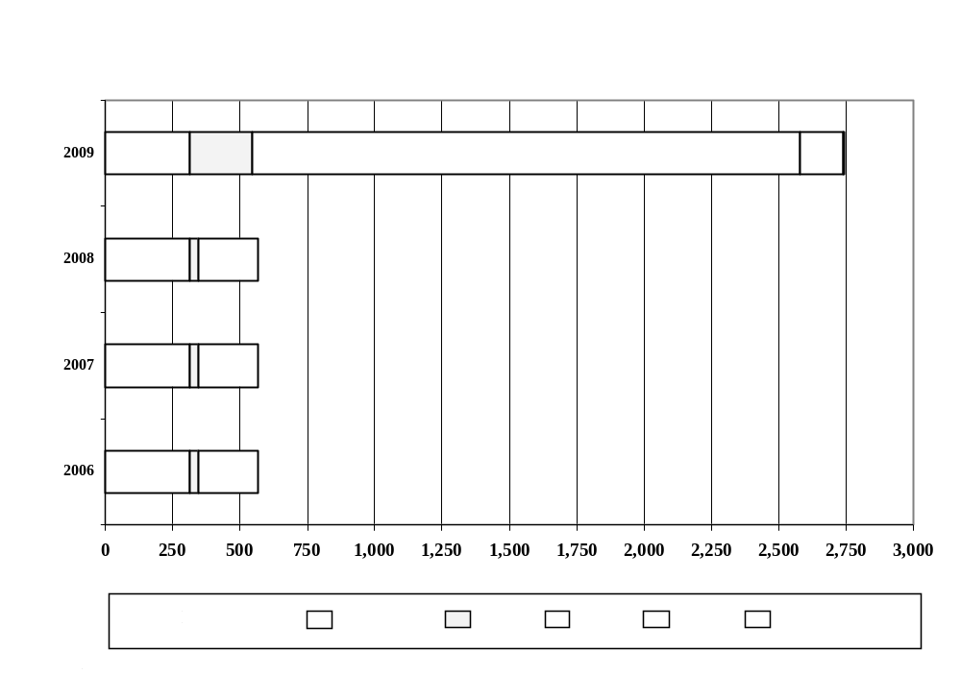

          - Table III.2 shows India's trade liberalization commitments under the Agreement on the basis of products' treatment at the HS 8-digit level organized by HS section product categories. Of the 11,629 tariff lines forming India's tariff schedule, 313 tariff lines where already MFN duty-free in 2006; an additional 252 tariff lines were liberalized upon entry into force of the Agreement (all of which are industrial products). In 2009, an additional 2,178 tariff lines are subject to liberalization; the 8,886 lines which remain subject to duties cover all HS sections.
Table III.2
India: Tariff elimination under the Agreement, by HS section
HS section and description | MFN  average  % | Total  No of lines | MFN duty free | No of duty-free lines under the Agreement in: |  | Remain dutiable
 |  |  |  | 2006 | 2009 | Remain dutiable
I Live animals and animal products | 30.2 | 342 | 0 | 0 | 127 | 215
II Vegetable products | 36.4 | 595 | 14 | 0 | 1 | 580
III Animal or vegetable fats and oils | 58.4 | 120 | 0 | 0 | 0 | 120
IV Prepared food etc. | 37.2 | 392 | 0 | 0 | 31 | 361
V Minerals | 11.8 | 311 | 1 | 2 | 51 | 257
VI Chemical and products | 14.9 | 2,242 | 6 | 129 | 492 | 1,615
VII Plastics and rubber | 15.0 | 589 | 2 | 21 | 47 | 519
VIII Hides and skins | 11.0 | 150 | 40 | 13 | 44 | 53
IX Wood and articles | 13.5 | 222 | 0 | 0 | 168 | 55
X Pulp, paper etc. | 13.7 | 279 | 12 | 1 | 147 | 119
XI Textile and articles | 14.8 | 1,947 | 6 | 0 | 203 | 1,740
XII Footwear, headgear | 15.0 | 114 | 0 | 0 | 18 | 96
XIII Articles of stone | 14.5 | 263 | 0 | 3 | 67 | 193
XIV Precious stones, etc. | 15.0 | 91 | 0 | 0 | 30 | 61
XV Base metals and products | 10.9 | 1,304 | 0 | 0 | 223 | 1,082
XVI Machinery | 12.9 | 1,745 | 193 | 65 | 211 | 1,277
Table III.2 (Cont'd)

XVII Transport equipment | 32.7 | 265 | 2 | 6 | 85 | 172
XVIII Precision equipment | 13.6 | 376 | 34 | 12 | 175 | 155
XIX Arms and ammunition | 15.0 | 21 | 0 | 0 | 2 | 19
XX Miscellaneous manufact'd articles | 15.0 | 239 | 0 | 0 | 49 | 190
XXI Works of art, etc. | 12.4 | 17 | 3 | 0 | 7 | 7
Total | 17.0 | 11,629 | 313 | 252 | 2,178 | 8,886
Source: Data provided by Indian Authorities.

Singapore's liberalization schedule
          - At entry into force of the Agreement, all but six of Singapore's tariff lines were duty-free on an MFN basis. Duties on these six lines were eliminated as of the date of entry into force of the Agreement.
          - Table III.3 shows Singapore's trade liberalization commitments under the Agreement on the basis of products' treatment at the HS 8-digit level organized by HS section product categories. The six lines not already duty-free on an MFN basis fall in Section IV, prepared food.
Table III.3
Singapore: Tariff elimination under the Agreement, by HS section
HS section and description | MFN  average  % | Total  No of lines | MFN duty free | No of duty-free lines under the Agreement in 2006
I Live animals and animal products | 0 | 338 | 338 | 0
II Vegetable products | 0 | 388 | 388 | 0
III Animal or vegetable fats and oils | 0 | 151 | 151 | 0
IV Prepared food etc. | 0 | 417 | 411 | 6
V Minerals | 0 | 212 | 212 | 0
VI Chemical and products | 0 | 1,287 | 1,287 | 0
VII Plastics and rubber | 0 | 588 | 588 | 0
VIII Hides and skins | 0 | 112 | 112 | 0
IX Wood and articles | 0 | 253 | 253 | 0
X Pulp, paper etc. | 0 | 271 | 271 | 0
XI Textile and articles | 0 | 1,185 | 1,185 | 0
XII Footwear, headgear | 0 | 74 | 74 | 0
XIII Articles of stone | 0 | 221 | 221 | 0
XIV Precious stones, etc. | 0 | 77 | 77 | 0
XV Base metals and products | 0 | 1,161 | 1,161 | 0
XVI Machinery | 0 | 2,202 | 2,202 | 0
XVII Transport equipment | 0 | 1,026 | 1,026 | 0
XVIII Precision equipment | 0 | 398 | 398 | 0
XIX Arms and ammunition | 0 | 28 | 28 | 0
XX Miscellaneous manufact'd articles | 0 | 287 | 287 | 0
XXI Works of art, etc. | 0 | 12 | 12 | 0
Total |  | 10,688 | 10,682 | 6
Source: Data provided by Singapore authorities.

Rules of origin
          - Disciplines regarding rules of origin are set out in Chapter 3, while rules relating to customs procedures are covered by Chapter 4.
          - The basic requirements for a product to be considered originating (Articles 3.3 and 3.4) are:
            - the product is wholly obtained in one of the Parties; or
            - the total value of materials originating in third parties does not exceed 60% of the FOB value of the product; and
            - the product is classified in a heading of the Harmonised System different from that in which all the non-originating materials used in its manufacture are classified; or
            - the product satisfies the product specific rules as specified in Annex 3A.
          - The import content test (MC) together with the change in tariff classification (CTC) at the heading level (CTH 4-digit) can be considered as the regime-wide rule of origin. The MC test requires a minimum of 40% local value content (combining the value of originating materials plus direct labour cost, direct overhead cost and profit) or a maximum permissible limit for non-originating materials of 60%.
          - Product specific rules contained in Annex 3A apply to selected products in 11 different HS Chapters: prepared foodstuffs, chemicals, plastics, paper, machinery, and measuring equipment. These product specific rules provide additional flexibility for certain products by specifying in many cases only a single rule with which the product must comply in order to attain originating status (either MC or CTH), or by combining the import content test with a change at the subheading, rather than the heading level.
          - Article 3.9 provides for bilateral cumulation between the Parties. Material in a finished product is considered originating if it satisfies the origin criteria in Article 3.3 (wholly obtained or produced) or Article 3.4 (not wholly obtained or produced). For such originating materials, the full value of the material can be considered when incorporated into the finished product.
          - There is no provision in the Agreement for a "tolerance rule" providing that non-originating materials which would otherwise not be accepted may nevertheless be used up to a specified percentage.
          - Article 3.6 lays down a list of insufficient working or processing operations carried out in the territory of the Parties that do not confer origin. Articles 3.10-3.11 deal with how certain materials (accessories, spare parts and tools, and packaging) are to be treated or valued when determining the origin of the goods. Article 3.13 deals with advance rulings, whereby an importer, exporter or producer of a good may request a written advance ruling on whether the good qualifies as an originating good.
          - Article 3.14 deals with the transport of goods through third parties.
Box III.1: Rules of Origin: Basic Features at a Glance
- Regime-wide rules of origin with product-specific exceptions.
- Product-specific rules apply to certain products in 11 different HS Chapters.
- Product specific criteria:
- MC or CTC only
- MC plus change at subheading level
- Change at subheading level only
- Bilateral cumulation between India and Singapore
- Absorption principle applies.
- No tolerance rule.
- Outward-processing not authorized.

Export duties and charges, and quantitative restrictions
          - Article 2.5 of the Agreement provides that neither Party may adopt or maintain any non-tariff measures on the export of any goods to the other Party except in accordance with its WTO rights and obligations or in accordance with other provisions of the Agreement.

Regulatory Provisions Of The Agreement

Standards

Technical barriers to trade
          - Chapter 5 lays down the provisions applying to standards and technical regulations. The Parties agree to implement the principles of mutual recognition that provide the most appropriate or cost-efficient approach to the removal or reduction of technical barriers to the trade in goods between them for products specified in Sectoral Annexes 5A and C. In particular, the Parties agree to accept the test reports and certification of results of conformity assessment of the other Party and accord each other mutual recognition of equivalence of mandatory requirements. In accordance with Article 2.4 of the WTO Agreement on Technical Barriers to Trade the Parties agree to use relevant international standards where they exist. As concerns the mutual recognition of conformity assessment, Chapter 5 provides for provisions to nominate designating authorities, the registration, verification and monitoring of conformity assessment bodies and their suspension and withdrawal. A Joint Committee on Mutual Recognition is established to implement the provisions of Chapter 5 and to resolve any questions or disputes relating to its application.
          - Sectoral Annex 5A lays down provisions for the mutual recognition of test reports (within one year of the entry into force of the Agreement) and of equipment certification (within a time frame to be agreed between the Parties) of telecommunications equipment including wire and wireless equipment, and terrestrial and satellite equipment. Sectoral Annex 5C lays down provisions for third party conformity assessment activities or requirements for product certification for new electrical and electronic equipment.

Sanitary and phytosanitary measures
          - Chapter 5 lays down the provisions applying to sanitary and phytosanitary measures. The Parties agree to implement the principles of mutual recognition that provide the most appropriate or cost-efficient approach to the removal or reduction of sanitary and phytosanitary barriers to the trade in goods between them for products specified in Sectoral Annex 5B.
          - In Sectoral Annex 5B the Parties agree to identify food products, on a product by product basis, to be covered by conformity assessment arrangements for the purpose of ensuring that food products exported by a Party meet the food standards/mandatory requirements of the other Party. Food products already subject to conformity assessment arrangements are egg products (pasteurised egg powder of whole egg, egg yolk and egg albumen); dairy products (milk powder, casein, whey protein concentrate, natural and processed cheese); and packaged drinking water.

Safeguard mechanisms

Global Safeguard Measures
          - According to Article 2.9.5, the Parties retain their rights and obligations under Article XIX of GATT 1994 and the WTO Agreement on Safeguards. A Party taking a safeguard measure under Article XIX and the Agreement on Safeguards may exclude imports from the other Party if such imports are not a substantial cause of serious injury or threat thereof.

Bilateral safeguards
          - Article 2.9 sets out the rules that apply to the imposition of a bilateral safeguard measure. A Party may impose a bilateral safeguard measure on an originating good if there is an increase in imports in absolute terms which causes or threatens to cause serious injury to the domestic industry of the importing Party producing a like or directly competitive good. Disciplines attached to such action include the need for prior investigation by the Party's competent authorities; scope and duration of the measure; progressive liberalization; prohibition of subjecting a good to both bilateral safeguards and safeguards applied in the WTO context; and compensation. The conditions applied to the use of bilateral safeguards are detailed in Table III.2.
Table III.2 Conditions applied to the application of bilateral safeguards
Requirements |  | Type of Safeguard
 |  | Bilateral
Trigger | Rise in imports | In absolute terms
Criteria | Serious injury or actual threat thereof | ✓
Measures allowed | Suspension of further duty reduction | ✓
 | Increase in duty rate | MFN rate in effect when measure was taken, or MFN rate in effect on day preceding start of investigation, whichever is lower
Timing | Maximum duration, including extension | 2 years plus 1 year extension
 | Safeguard measure vis-à-vis the transition period of the good concerned | No specific link to the transition period
Conditions or limitations | Information of the institution of a proceeding through written notice | ✓
 | Consultation | ✓
 | Prior investigation | ✓
 | Compensation | For measures exceeding 2 years
 | Possibility of retaliation | ✓
 | Prohibition of bilateral and global safeguards on the same good simultaneously | ✓
Source: WTO Secretariat

Restrictions to safeguard balance of payments
          - The Agreement incorporates Article XII of the GATT 1994 and the Understanding on Balance of Payments Provisions.

Anti-dumping
          - Article 2.7 of the Agreement lays down the provisions that apply to anti-dumping investigations. Before proceeding to initiate an anti-dumping investigation, the Parties agree to give each other seven working days notice. Where originating goods are subject to an anti-dumping investigation, the export price of such goods is to be determined in accordance with Article 2.4 of the WTO Agreement on Anti-Dumping.

Subsidies, state-aid and countervailing measures
          - In Article 2.8, the Parties reaffirm their commitment to abide by the provisions of the WTO Agreement on Subsidies and Countervailing Measures.

Other regulations

Customs-related procedures
          - Customs procedures related to rules of origin are detailed in Articles 3.15-3.18, Annex 3B, and Chapter 4. Articles 3.15-3.18 lay out disciplines for documentation requirements and verification of origin. Annex 3B contains the operational procedures which apply to the issuance and verification of the certificate of origin and other related administrative matters. The certificate of origin is to be issued by the government authority designated by the exporting Party and notified to the other Party. Annex 3B also lays down provisions covering applications for pre-exportation verification of the origin, pre-exportation examination, issuance of certificate of origin, presentation, and action against fraudulent acts. Chapter 4 lays down the provisions for transparency, risk management, paperless trading, denial of preferential tariff treatment, verification of certificates of origin, advance rulings, sharing of best practices, and confidentiality.

Provisions on Trade in Services and Investment

Scope And Definitions
          - The liberalization of trade in services is mainly governed by Chapter 7. It applies to measures affecting cross-border trade in services taken by central, regional or local governments and authorities of the Parties; and non-governmental bodies in the exercise of powers delegated by central, regional or local government or authorities. The provisions of Chapters 7 do not apply to: subsidies granted by the Parties, services supplied in the exercise of governmental authority, and shell companies located in the territory of either Party with negligible or nil business operation or with no real and continuous business activities carried out in the territory of either Party.
          - Chapter 7 contains the definitions which apply to measures taken by central, regional or local authorities of the Parties affecting trade in services in all four modes of supply, as defined in the GATS mutatis mutandis. Thus, measures affecting Mode 3 are covered by this Chapter except with respect to investors and investments in both services and non-services sectors, which is dealt with in Chapter 6 – Investment. A "natural person of a Party" is defined as a national of a Party, or a permanent resident in that Party. The definition of "juridical person" mirrors that found in Article XXVIII of the GATS. For the purposes of the supply of audio-visual, education, financial and telecommunications services through commercial presence, juridical persons must be owned or controlled by natural persons of the other Party. The provisions of Chapter 6 do not apply to subsidies granted by the Parties.
          - As regards commitments made in trade in services, the Agreement follows a "positive list" approach, as in the GATS. For each country there is a list of horizontal exceptions, followed by a schedule of commitments based on the Central Product Classification (CPC) in Annexes 7A (India) and 7B (Singapore). In the case of investment, India's schedule of commitments containing the conditions and qualifications on national treatment are set out in Annex 6A, while Annex 6B contains the exceptions which Singapore maintains with respect to sectors, subsectors or activities.

Denial Of Benefits
          - Under Article 7.23, a Party may deny the benefits of Chapter 7 to a service supplier of the other Party if it establishes that the service is supplied from or in the territory of a non-Party, and in the case of the supply of a maritime transport service, if it establishes that the service is supplied by a vessel registered under the laws of a non-Party, and by a person which operates and/or uses the vessel in whole or in part but which is of a non-Party. In addition, benefits may be denied if the Party establishes that persons of a non-Party own or control the service supplier in the case of services supplied through commercial presence, or in the case of supply of a service from or in the territory of the other Party, if the Party establishes that the service is supplied by a service supplier owned or controlled by a person of the denying Party.
          - Under Article 6.9, a Party may deny the benefits of the investment chapter to an investor that is an enterprise of the other Party where the denying Party establishes that the enterprise has no substantial business operations in the territory of the other Party, or investors of the denying Party own or control the enterprise.

Market Access
          - Market access provisions in trade in services are laid down in Article 7.3 of the Agreement. The Parties agree to accord services and suppliers of the other Party treatment no less favourable in the four modes of supply as provided for in the Parties' schedules of commitments. The Parties also commit themselves, as in GATS Article XVI, not to maintain or adopt six types of measures that would require an economic needs test, impose a quantitative limitation on certain number of aspects or a requirement for the type of legal entity through which a supplier may provide a service, unless otherwise specified in their schedules.

National Treatment, Mfn, Standard Of Treatment
          - Under Article 7.4, the Parties commit themselves for the sectors covered in their schedules, and subject to the conditions therein, to grant services and service suppliers of the other Party treatment no less favourable than that granted to their own like services and service suppliers. The Parties understand that treatment no less favourable can be granted through either formally identical or formally different treatment, as long as this difference does not change the conditions of competition.
          - According to Article 7.6, if a Party enters into any agreement on trade in services with a non-Party after this Agreement enters into force, it shall consider offering the other Party treatment no less favourable than that offered under that Agreement.
          - According to Article 7.20, the provisions of market access and national treatment do not apply to laws, regulations or requirements governing government procurement.

Movement Of Natural Persons
          - Rights and obligations with respect to the movement of natural persons are contained in Chapter 9. This Chapter applies to natural persons of a Party when they are service sellers or suppliers, sellers of goods, investors, or employed by an investor in respect of an investment by that investor in the territory of the other Party, and advisors. The definition of natural persons includes nationals of a Party and permanent residents. The provisions of Chapter 9 do not apply to measures pertaining to citizenship, permanent residence, or employment on a permanent basis.
          - The Parties agree to grant upon application by a business visitor of the other Party, a five year multiple entry visa with the right to temporary entry for a period of up to two months, which may be extended for one month upon request. Short-term services suppliers may be granted temporary entry for an initial period of up to 90 days, with possibility of extension of another 90 days. Intra-corporate transferees are granted an initial visa valid for up to two years, which may be extended for up to three years at a time for a total term not exceeding eight years. Professionals (having a specialized occupation as listed in Annex 9A) may be granted temporary stay for up to one year.
          - Spouses or dependants of natural persons who have been granted the right to long term temporary entry may be granted the right to work as managers, executives or specialists, subject to relevant licensing, administrative and registration requirements.

Investment
          - Chapter 6 applies to investors of a Party and to their investments in the territory of the other Party whether made before or after the entry into force of the Agreement. Chapter 6 requires each Party to accord national treatment (Article 6.3) to investors and investments of the other Party with respect to the establishment, acquisition, expansion, management, conduct, operation, liquidation, sale and transfer of investments in the sectors listed in Annex 6A (India) and Annex 6B (Singapore).
          - Article 6.4 contains provisions relating to compensation for losses, while Article 6.5 deals with expropriation. In Article 6.6, the Parties agree to ensure the free transfer of capital and returns from any investments.

Domestic Regulation
          - Article 7.10 contains provisions on domestic regulation, in particular governing the maintenance of tribunals and procedures for the review of decisions affecting trade in services (Article 7.10.2) and for the treatment of applications for authorization (Article 7.10.4), which mirror the corresponding GATS provisions (Article VI.2-3). The Parties agree to incorporate the results of negotiations on disciplines under GATS Article VI.4 into the Agreement and endorse the GATS criteria of transparency and objectivity, not unnecessarily burdensome, and not a restriction on the supply of the service for such measures. In the interim, they agree to apply licensing and qualification requirements and technical standards in accordance with such measures. In sectors where specific commitments regarding professional services are undertaken, the Parties agree to provide for adequate procedures to verify the competence of professionals of the other.

Mutual Recognition
          - Article 7.11 contains provisions on recognition of standards or criteria for the authorization, licensing or certification of services suppliers. The Parties agree to ensure that their respective professional bodies in the service sectors of accounting and auditing, architecture, medical (doctors), dental and nursing negotiate and conclude arrangements providing for mutual recognition of licenses or certifications within twelve months of the date of entry into force of the Agreement. Any delay or failure to conclude such agreements is not considered as a breach of a Party's obligations, nor subject to dispute settlement.
          - Article 7.11.3 provides that one Party may request the other to enter into negotiations on mutual recognition arrangements in services sectors not already subject to such disciplines under the Agreement. In the event that a Party accords recognition to a non-Party, it will upon request grant the opportunity for the other Party to negotiate a similar arrangement. If a Party accords recognition autonomously, it will grant the opportunity for the other Party to demonstrate that education, experience, licenses or certifications obtained or requirements met should be recognized. The Agreement's provisions on dispute settlement do not apply to disputes arising from the provisions of mutual recognition agreements.

Liberalization Commitments
          - The schedules of commitments are contained in Annexes 7A and 7B for India and Singapore, respectively; they are modelled on the GATS schedules with respect to the sectoral classification and the separation of sector specific and horizontal commitments, the latter applying to all sectors listed. The schedules include limitations and conditions on market access and national treatment, the undertakings relating to additional commitments and where appropriate, the time frame for implementation. Article 7.8 provides that a Party may modify or withdraw any commitment in its Schedule by giving three months advance written notification; it must then enter into negotiations at the request of the other Party with a view to finding any compensatory adjustment. If an agreement is not reached, the case may be referred to dispute settlement in accordance with Chapter 15.
          - Under Article 7.5, the Parties may negotiate commitments with respect to measures affecting trade in services not subject to scheduling, including those regarding qualifications, standards or licensing matters. In Article 7.9, the Parties agree to review their schedules of specific commitments at least once every three years, or earlier at the request of the other Party, with a view to eliminating substantially all remaining discrimination between the Parties in the services covered by the Agreement.
          - In the Agreement there are separate annexes on financial services (7C) and telecommunications (7D), generally corresponding to the respective GATS annexes and the Reference Paper on basic telecommunications. Notably, paragraph 5 of the financial services annex contains expanded regulatory provisions related to transparency. For example, each Party shall, to the extent practicable, make available in advance any regulations of general application relating to the supply of financial services that it proposes to adopt, provide interested persons and the other Party a reasonable opportunity to comment on such proposed regulations.

Singapore

Horizontal commitments / exceptions
          - Singapore and India have both included in the Agreement horizontal commitments and limitations which are not found in their respective GATS schedules. For Singapore, under national treatment, modes 1 through 4 are unbound for all subsidies and grants and any conditions attached to the receipt or continued receipt of such subsidies or grants.

Sector specific commitments / exceptions
          - For business services, under the Agreement Singapore has added under professional services limited commitments for legal consultancy services for Indian law, urban planning and the category of other professional services (not defined), with modes 1 and 3 unbound and no restrictions on mode 2 for market access, as well as more liberalized commitments for integrated engineering and for midwives, nurses and physiotherapists. For nearly all other professional services found in Singapore's GATS schedule, commitments are significantly liberalized under the Agreement, typically with no market access restrictions for modes 1, 2, and 3. Computer services are further liberalized, with expanded coverage compared to the GATS. Commitments on R&D, real estate, and rental/leasing services have been added under the Agreement, and the coverage of other business services is greatly expanded.
          - For communications services, commitments under the Agreement match Singapore's GATS commitments, both for telecommunications and audiovisual services. New sectors added under the Agreement are distribution, covering commission agents, wholesale trade, retailing, and franchising services; education services, covering secondary and post-secondary technical and vocational education services, other higher education services, adult education courses, and short-term training including English-language courses; environmental services, excluding new environmental services; health and related social services, covering hospital services, ambulance services, and acute care hospitals, nursing homes and convalescent hospitals; and other services not covered elsewhere, with commitments on washing, hairdressing and funeral services.
          - For financial services, banking commitments under the Agreement in many cases match Singapore's GATS commitments. Regarding the acceptance of deposits, up to a maximum of three bank licences with Qualifying Full Bank (QFB) privileges may be granted to Indian banks with or without operations in Singapore. Quantitative limits on the number of Wholesale Bank (WB) licences are removed for Indian banks with or without operations in Singapore under the Agreement. For lending of all types, the mode 3 commitment states that financial institutions extending Singapore dollar (S$) credit facilities exceeding S$5 million per entity to non-resident financial entities or arranging S$ equity or bond issues for non-residents, must ensure that where the S$ proceeds are to be used outside Singapore, they are swapped or converted into foreign currency upon draw-down or before remittance abroad. For participation in issues of securities, the mode 3 commitment states that banks' and merchant banks' membership on any securities exchange or futures exchange established in Singapore must be held through subsidiaries incorporated in Singapore. In insurance, commitments under the Agreement have been further liberalized, compared with Singapore's GATS schedule, with the 49% foreign equity limitation in mode 3 removed for both life and non-life insurance.
          - For tourism and travel related services, the sub-category of tourism and travel related services (not defined) is also committed under the Agreement. For recreational, cultural and sporting services, additional sub-sectors committed under the Agreement are entertainment services, archive services, museum services, parks services, other cultural services, and sporting and other recreational services (except gambling).
          - For transport services, additional maritime transport sub-sectors committed under the Agreement are international towage, classification societies, storage and warehousing, freight forwarding, and maintenance and repair of vessels. Additional transport sectors committed under the Agreement comprise internal waterways, covering passenger and freight transportation, rental of vessels with crew, and pushing and towing services; air transport, covering repair and maintenance, selling and marketing, and rental of aircraft with crew; space transport; rail transport, covering passenger and freight transportation, pushing and towing, maintenance and supporting services; road transport, covering rental services, freight transportation, maintenance, parking and supporting services; and pipeline transport, covering transportation of fuels, and transportation of other goods; as well as the category of services auxiliary to all modes of transport except maritime transport services, covering storage and warehousing, and freight forwarding services.

India

Horizontal commitments / exceptions
          - For India, horizontal commitments and limitations under mode 3 not found in its GATS schedule are, for market access, that prior Government approval shall be required where a joint venture or technology transfer/trademark agreement existed in the ‘same’ field except in the case of investment by Venture Capital Funds registered with the Security & Exchange Board of India or where in the ‘existing’ joint venture investment by either of the parties is less than 3% or where the existing joint venture is defunct or sick.
          - Under national treatment for mode 3, the following additional provisions apply under the Agreement: for transfer of equity in an existing company to the investor of the other party where Security & Exchange Board of India (Substantial Acquisition of Shares and Takeovers) Regulations, 1997 as amended, are applicable; repatriation of sale proceeds of immovable property is subject to prior approval by the Reserve Bank of India; taxation laws for domestic and foreign service suppliers, under the provisions of the Income tax Act, 1961, shall apply; and subsidies, where granted, shall be available only to domestic service suppliers.
          - Applicable to market access and national treatment, for both mode 4 and mode 3, is that access to Scheduled and Tribal Areas covered under the V and VI Schedule of the Constitution of India may be denied. Additionally applicable to mode 4 is that special treatment may be provided to Scheduled Castes, Scheduled Tribes and weaker sections of society, as laid down in the Constitution of India as well as various legislation.

Sector specific commitments / exceptions
          - For business services, India has GATS commitments in professional services only for engineering. Under the Agreement, engineering is further liberalized, while commitments have also been made for accountancy, taxation, architectural, integrated engineering, urban planning, medical and dental, veterinary and midwives, nurses and physiotherapists. Both computer and R&D services are further liberalized, with expanded coverage compared to the GATS. Commitments on real estate services and rental/leasing services have been added under the Agreement, while the coverage of other business services is greatly expanded.
          - For communications services, the Agreement provides expanded coverage and fewer limitations compared to India's GATS commitments. In voice telephony, the foreign equity limit is raised to 49%, from 21%. For all sub-sectors, mode 2 is unrestricted, compared to unbound under GATS. Additional sub-sectors committed under the Agreement are: packet switched data transmission, V-Sat, radio paging, internet and infrastructural services. Commitments for audiovisual services are unchanged under the Agreement compared with India's GATS schedule.
          - For construction and related engineering services, the Agreement again provides significantly expanded coverage, and fewer limitations, compared to India's GATS commitments. New sectors added under the Agreement are distribution, covering both commission agents and wholesale trade; recreational services, covering library, archive and sporting services; and transport, with extensive commitments on maritime transport and some on air transport, notably including international freight transport, together with maintenance and repair of aircraft. In health services and tourism, coverage remains the same as under GATS, but with modes 1, 2 and 3 significantly liberalized for hospital services and fully liberalized for hotels and restaurants as well as for travel agencies and tour operators.
          - For financial services, additional banking sub-sectors committed under the Agreement are money broking, and provision and transfer of financial information. Under market access, each of the three Singapore banks named in Article 7.1(e) is limited to “one mode of presence” through (a) establishing not more than one wholly owned subsidiary or (b) operating through branches in India or (c) establishing a joint venture company in India, to supply banking services in India. For banks that operate as branches, fifteen branches over four years for the three Singapore banks named in Article 7.1 (e) would be allowed. In addition, FDI by Singapore banks is permitted in private sector banks subject to the condition that total investment (foreign direct investment and foreign institutional investment) shall not exceed 74% but subject to the limitation of ‘one mode presence’. In insurance, coverage under the Agreement has been significantly expanded, with the life insurance sub-sector added, and full coverage granted for non-life insurance (which under India's GATS commitments is limited to insurance of freight). Under market access, the unbound limitation for mode 3 is replaced in the Agreement with a 26% foreign equity limitation. In addition, each of the three Singapore banks named in Article 7.1(e) is permitted to incorporate one insurance company.

Safeguard Actions On Services Trade And Investment
          - Article 7.14 prohibits the Parties from taking safeguard action against services and service suppliers of the other Party from the date of entry into force of the Agreement and agree to review the issue of safeguard measures in the context of developments in international fora of which both Parties are members.
          - In the event of serious balance of payments and external financial difficulties or threat thereof, Article 7.17 permits the Parties to maintain or adopt restrictions on trade in services, while Article 6.7 permits the Parties to adopt or maintain restrictions on payments or transfers related to investments. Such measures are to be consistent with the Articles of Agreement of the IMF, avoid unnecessary damage to the commercial, economic and financial interests of the other Party, not exceed those necessary, be temporary and be applied on a national treatment basis. Restrictions are subject to consultations between the Parties and to prompt notification.

provisions affecting trade in goods, services and investment

E-Commerce
          - Chapter 10 contains the provisions applicable to e-commerce between the Parties. Under Article 10.4, the Parties agree not to apply customs duties or other duties, fees or charges on or in connection with the import or export of digital products by electronic transmission. The Parties also undertake to accord treatment no less favourable than they accord to their own like digital products in respect of all measures affecting digital products. The provisions on e-commerce do not apply to government procurement, nor to measures affecting broadcasting, as defined by each Party under its domestic law, which may include webcasting, cablecasting and video on demand.

Intellectual Property
          - In Chapter 11 of the Agreement the Parties agree to cooperate on matters related to intellectual property and plant varieties. Cooperation may take the form of the organization of symposia, seminars, workshops and other training programmes, and collaboration in projects to promote the effective use and application of intellectual property rights.

Government Procurement
          - As stated above, in accordance with Article 7.20, the provisions of market access and national treatment do not apply to laws, regulations or requirements governing government procurement in trade in services. There are no provisions in the Agreement relating to Government Procurement in trade in goods.

Sector-Specific Provisions Of The Agreement
          - No sector-specific provision per se exists in the Agreement.

Institutional Provisions Of The Agreement

Exceptions and reservations
          - Article 2.13 incorporates Articles XX and XXI of the GATT 1994 into the Agreement.

Accession
          - According to Article 16.4, the Agreement is open to accession or association by any country or separate customs territory.

Institutional framework
          - Article 16.2 provides for the establishment of contact points to facilitate communication between the Parties. Article 16.3 provides for the Parties to meet within a year of the date of entry into force of the Agreement and then biennially or otherwise as appropriate to review the Agreement. -The Parties may establish any working groups or committees on an ad hoc basis or otherwise to study and recommend appropriate measures to resolve any issues arising from the implementation or application of the Agreement and to consider, at either Party's request, fresh concessions or issues not already dealt with by the Agreement.

Dispute settlement
          - Chapter 15 sets out the procedures that apply to the settlement of disputes relating to the application or interpretation of the Agreement. In the event that consultations between the Parties fail to settle the dispute an arbitral tribunal may be appointed. The arbitral tribunal shall release its final report within 60 days of its formation. The Parties should comply with the arbitral tribunal's award within a reasonable period of time. The details of the dispute settlement provisions of the Agreement are outlined in Table V.1.
Table V.1
Synopsis of the Agreement's Dispute Settlement Provisions
Consultations (Art. 15.3)
Request for Arbitral Tribunal (Art. 15.5)
Composition (Art 15.6)
Rules of procedure (Art. 15.8)
Final Report issued (Art. 15.8.12)
Reasonable period of time for Implementation of findings (Art. 15.11)
Within 60 days, if consultations fail
Appointment of Arbitral Tribunal
(Art. 15.5)
Within 30 days
Within 60 days of formation of Arbitral Tribunal
Final Report made public (Art. 15.8.12)
Within 10 days after release to parties
Within 45 days of release of report

Relationship with other agreements concluded by the Parties
          - In Article 16.5 the Parties affirm their existing rights and obligations with respect to each other under existing bilateral and multilateral agreements to which they are both parties, including the WTO Agreement. In the event of any inconsistency between this Agreement and any other agreement to which both are parties, they agree to consult with each other to find a mutually satisfactory solution.
          - Table V.2 lists the regional trade agreements (RTAs), (notified and non-notified to the GATT/WTO and in force), as of January 2008 to which India and Singapore are parties.
Table V.2 India and Singapore: Participation in other RTAs (notified and non-notified in force), January 2008
Partner/  Agreement | Date of entry  into force |  | Type of  agreement | GATT/WTO Notification
Partner/  Agreement |  |  | Type of  agreement | Year |  |  | WTO Provision
india
Sri Lanka | 01.03.00 |  | Goods | 2002 |  |  | Enabling Clause
SAPTA | 07.12.95 |  | Goods | 1997 |  |  | Enabling Clause
GSTP | 19.04.89 |  | Goods | 1989 |  |  | Enabling Clause
APTA (Bangkok Agreement) | 17.06.76 |  | Goods | 1976 |  |  | Enabling Clause
Tripartite (Egypt, Yugoslavia)* | 01.04.68 |  | Goods | 1968 |  |  | Enabling Clause
Chile | 16.08.07 |  | Goods | Not notified
Bhutan | 29.07.06** |  | Goods | Not notified
SAFTA | 01.01.06 |  | Goods | Not notified
Afghanistan | 06.03.03 |  | Goods | Not notified
Nepal | 06.03.02** |  | Goods | Not notified
singapore
Trans-Pacific Strategic Economic Partnership (Brunei Darussalam, Chile, New Zealand) | 28.05.06 | Goods & Services |  |  | 2007 | GATT Art. XXIV & GATS Art. V
Panama | 24.07.06 | Goods & Services |  |  | 2007 | GATT Art. XXIV & GATS Art. V
Republic of Korea | 02.03.06 | Goods & Services |  |  | 2006 | GATT Art. XXIV & GATS Art. V
Jordan | 22.08.05 | Goods & Services |  |  | 2006 | GATT Art. XXIV & GATS Art. V
United States | 01.01.04 | Goods & Services |  |  | 2003 | GATT Art. XXIV & GATS Art. V
Australia | 28.07.03 | Goods & Services |  |  | 2003 | GATT Art. XXIV & GATS Art. V
EFTA | 01.01.03 | Goods & Services |  |  | 2003 | GATT Art. XXIV & GATS Art. V
Japan | 30.11.02 | Goods & Services |  |  | 2002 | GATT Art. XXIV & GATS Art. V
New Zealand | 01.01.01 | Goods & Services |  |  | 2001 | GATT Art. XXIV & GATS Art. V
AFTA | 28.01.92 | Goods |  |  | 1992 | Enabling Clause
GSTP | 19.04.89 | Goods |  |  | 1989 | Enabling Clause

Source: WTO Secretariat

SAPTA Members are Bangladesh, Bhutan, Maldives, Nepal, Pakistan, Sri Lanka
APTA Members are Bangladesh, China, Republic of Korea, Laos, Sri Lanka
AFTA Members are Brunei Darussalam, Cambodia, Indonesia, Laos, Malaysia, Myanmar, Philippines, Thailand, Vietnam

* Inactive

** Date of Renewal

ANNEX

Indicators of trade liberalization under the Agreement

          - A comparison between the scheduled elimination of tariffs applied to the Parties' mutual imports and the duty rates applied by India and Singapore to MFN imports is shown in Tables A.1 (India) and A.2 (Singapore) below, according to agricultural, non-agricultural and total products. Applied MFN duty rates in 2005 serve as a basis for the comparison.
          - India has a variable MFN tariff structure. Its (unweighted) average MFN rate (2006) is 17.0% on all goods, with a higher average tariff applied to agricultural goods than to non-agricultural products. Only 2.7% of India's tariff lines are duty-free at an MFN level. On entry into force, Singapore's exporters enjoyed a relative margin of preference of 10.2% on non-agricultural products vis-à-vis the prevailing average MFN tariff in 2006, and a relative margin of preference of 1.3% in agricultural goods.
Table A.1
India: Indicators of MFN tariff rates and preferential rates for imports from Singapore
Origin  of  goods | Year | ALL PRODUCTS |  |  | Agricultural productsª |  |  | Non agricultural products
Origin  of  goods | Year | Average applied tariff |  | Share of duty-free tariff lines  (%) | Average applied tariff |  | Share of duty-free tariff lines  (%) | Average applied tariff |  | Share of duty-free tariff lines  (%)
Origin  of  goods | Year | Overall  (%) | On dutiable^{b}  (%) | Share of duty-free tariff lines  (%) | Overall  (%) | On dutiable^{b}  (%) | Share of duty-free tariff lines  (%) | Overall  (%) | On dutiable^{b}  (%) | Share of duty-free tariff lines  (%)
MFN | 2006 | 17.0 | 17.5 | 2.7 | 35.0 | 36.1 | 3.1 | 14.5 | 14.9 | 2.6
Singapore | 2006 | 15.7 | 16.5 | 4.9 | 34.5 | 35.6 | 3.1 | 13.0 | 13.7 | 5.1
 | 2007 | 14.7 | 15.4 | 4.9 | 34.1 | 35.1 | 3.1 | 11.9 | 12.5 | 5.1
 | 2008 | 13.5 | 14.2 | 4.9 | 33.5 | 34.6 | 3.1 | 10.6 | 11.2 | 5.1
 | 2009 | 12.3 | 16.1 | 23.6 | 33.0 | 36.9 | 10.5 | 9.3 | 12.5 | 25.5
a WTO definition.
b "on dutiable" excludes duty-free tariff lines.
Source: Data provided by the Indian authorities.

          - Singapore's tariff structure is duty free on an MFN basis for all but six tariff lines. These lines are liberalized upon entry into force of the Agreement, resulting in complete duty-free treatment for India's exports to Singapore.
Table A.2
Singapore: Indicators of MFN tariff rates and preferential rates for imports from India
Origin  of  goods | Year | ALL PRODUCTS |  |  | Agricultural productsª |  |  | Non agricultural products
Origin  of  goods | Year | Average applied tariff |  | Share of duty-free tariff lines  (%) | Average applied tariff |  | Share of duty-free tariff lines  (%) | Average applied tariff |  | Share of duty-free tariff lines  (%)
Origin  of  goods | Year | Overall  (%) | On dutiable^{b}  (%) | Share of duty-free tariff lines  (%) | Overall  (%) | On dutiable^{b}  (%) | Share of duty-free tariff lines  (%) | Overall  (%) | On dutiable^{b}  (%) | Share of duty-free tariff lines  (%)
MFN | 2006 | 0.0 | 0.0 | 99.9 | 0.0 | 0.0 | 99.5 | 0.0 | 0.0 | 100.0
India | 2006 | 0.0 | 0.0 | 100.0 | 0.0 | 0.0 | 100.0 | 0.0 | 0.0 | 100.0
a WTO definition.
b "on dutiable" excludes duty-free tariff lines.
Source: Data provided by Singapore authorities.

          - Table A.3 shows the market access opportunities in Singapore for India's top 25 exports, which in 2003-2005 accounted on average for 43.1% of India's global exports. The table shows at which year all HS 8-digit tariff lines corresponding to the product definition (i.e. applying to the 6-digit HS code used to capture the volume of trade) will become duty-free in Singapore.
          - India's top 25 exports cover a total of 128 HS 8-digit tariff lines in Singapore's tariff schedule. All of these products were already subject to duty-free MFN rates.
Table A.3
Market access opportunities in Singapore under the agreement, for India's top 25 exports
India's top export products in 2003-05 |  | Access Conditions to Singapore's import markets
HS number and description of the product | Share in global exports  (%) | Average MFN applied rate  (%) | Number of tariff lines
HS number and description of the product | Share in global exports  (%) | Average MFN applied rate  (%) | Duty-free | Dutiable
710239 Diamonds, non-industrial other than unwkd./simply sawn/cleaved/bruted | 11.9 | 0.0 | 1 | 0
271019 Petroleum oils & oils obt. from bituminous mins. (excl. crude) & preps. | 6.5 | 0.0 | 18 | 0
711319 Articles of jewellery & parts thereof , of oth. precious metal | 3.3 | 0.0 | 2 | 0
260111 Iron ores & concs. (excl. roasted iron pyrites) | 2.9 | 0.0 | 1 | 0
271011 Light petroleum oils & preps. | 2.2 | 0.0 | 14 | 0
294200 Organic comps. n.e.s. in Ch.29 | 1.6 | 0.0 | 1 | 0
100630 Semi-milled/wholly milled rice, whether or not polished/glazed | 1.5 | 0.0 | 14 | 0
300490 Medicaments (excl. of 30.02/30.05/30.06) | 1.4 | 0.0 | 29 | 0
610910 T-shirts, singlets & oth. vests, knitted or crocheted, of cotton | 1.1 | 0.0 | 2 | 0
030613 Shrimps & prawns, whether or not in shell, frozen | 1.0 | 0.0 | 1 | 0
620630 Women's/girls' blouses, shirts & shirt-blouses (excl. knitted or crocheted) | 1.0 | 0.0 | 1 | 0
721049 Flat-rolled prods. of iron/non-alloy steel, of a width of 600mm/more | 0.9 | 0.0 | 2 | 0
230400 Oil-cake & oth. solid residues, whether or not ground/in pellets | 0.9 | 0.0 | 1 | 0
630492 Textile furnishing arts. other than bedspreads (excl. of 94.04) | 0.8 | 0.0 | 4 | 0
620520 Men's/boys' shirts (excl. knitted or crocheted), of cotton | 0.8 | 0.0 | 1 | 0
999999 Commodities not specified according to kind | 0.8 |  |  | 0
870899 Parts & accessories of the motor vehicles of 87.01-87.05, n.e.s. in 87.06-8 | 0.7 | 0.0 | 11 | 0
080132 Cashew nuts, shelled | 0.6 | 0.0 | 1 | 0
630790 Other made-up textile arts., incl. dress patterns, n.e.s. | 0.6 | 0.0 | 6 | 0
740311 Cathodes & sections of cathodes, of ref. copper, unwrought | 0.5 | 0.0 | 1 | 0
970190 Collages & sim. decorative plaques | 0.5 | 0.0 | 3 | 0
020230 Meat of bovine animals, frozen, boneless | 0.5 | 0.0 | 1 | 0
610510 Men's/boys' shirts, knitted or crocheted, of cotton | 0.5 | 0.0 | 1 | 0
380810 Insecticides, put up in forms or packings-RS/as preps./arts. | 0.5 | 0.0 | 9 | 0
711719 Imitation jewellery, of base metal | 0.4 | 0.0 | 3 | 0
Total of above | 43.1 |  | 128 | 0
Source: Data provided by Singapore authorities, and UNSD, Comtrade Database.

          - Like Table A.3, Table A.4 shows the market access opportunities in India for Singapore's top 25 exports (at the HS 6-digit level), which accounted on average for 59% of Singapore's exports to the world in 2003-05. The table shows in which year all HS 8-digit tariff lines corresponding to the product definition (i.e. applying to the 6-digit HS code used to capture the volume of trade) will become duty-free in India.
          - Singapore's top 25 exports cover a total of 108 HS 8-digit tariff lines in India's tariff schedule. Fourteen of Singapore's top 25 exports (which account for 57 HS 8-digit lines and 40.4% of Singapore's average global exports in the period 2003-05) already benefit from zero MFN duties in India's market, one product (accounting for 0.5% of Singapore's average global exports) gains immediate duty-free access and seven products are granted duty-free access in 2009. Seven of Singapore's top 25 export products remain subject to duties. The margin of preference granted to Singapore by India under the Agreement varies from 0 to 12.2 percentage points.
Table A.4
Market access opportunities in India under the Agreement, for Singapore's top 25 exports
Singapore's top export products in 2003-05 |  | Access Conditions to India's import markets
 |  | MFN |  |  | Duty-free in: |  |  | Remain
HS number and description of the product | Share in global exports  (%) | Average MFN applied rate  (%) | Number of tariff lines |  | 2006 | 2009 |  | Dutiable
HS number and description of the product | Share in global exports  (%) | Average MFN applied rate  (%) | Duty-free | Dutiable | Number of tariff lines
854229 Monolithic integrated circuits, other than digital | 12.2 | 0.0 | 2 | 0
271019 Petroleum oils & oils obt. from bituminous mins. (excl. crude) & preps. | 6.6 | 10.0 | 0 | 9 |  |  | 9
847330 Parts & accessories (excl. covers, carrying cases and the like) | 6.5 | 0.0 | 9 | 0
847170 Storage units (of auto. data processing machines) | 5.5 | 0.0 | 8 | 0
854221 Monolithic integrated circuits, digital | 5.4 | 0.0 | 1 | 0
999999 Commodities not specified according to kind | 3.4 |  | 0 | 0
271011 Light petroleum oils & preps. | 3.2 | 10.0 | 0 | 6 |  |  | 6
852520 Transmission app. for radio-telephony/radio-telegraphy/radio-broadcasting | 2.9 | 0.0 | 11 | 0
854260 Hybrid integrated circuits | 2.0 | 0.0 | 1 | 0
854290 Parts of the electronic integrated circuits & microassemblies of 85.42 | 1.4 | 0.0 | 1 | 0
852990 Parts suit. for use solely/princ. with the app. of 85.25-85.28 | 1.0 | 15.0 | 0 | 3 | 2 | 1
847160 Input/output units (of auto. data processing machines) | 1.0 | 0.0 | 14 | 0
843143 Parts suit. for use solely/princ. with the boring/sinking mach. of 8430.41 | 0.9 | 15.0 | 0 | 2 |  |  | 2
847180 Automatic data processing machine units (excl. of 8471.50-5471.70) | 0.9 | 0.0 | 1 | 0
293090 Organo-sulphur comps.  (excl. of 2930.10-2930.40) | 0.7 | 15.0 | 0 | 9 | 8 |  | 1
292250 Amino-alcohol-phenols, amino-acid-phenols & oth. amino-comps. with oxygen | 0.7 | 15.0 | 0 | 10 |  | 10
853690 Electrical app. for switching/protecting electrical circuits | 0.7 | 15.0 | 0 | 4 | 1 |  | 3
852491 Recorded media for repr. phenomena other than sound/image | 0.7 | 0.0 | 5 | 0
854129 Transistors (excl. photosensitive transistors) | 0.6 | 0.0 | 1 | 0
853400 Printed circuits | 0.5 | 0.0 | 1 | 0
880330 Parts of aeroplanes/helicopters, other than propellers, rotors | 0.5 | 3.0 | 0 | 1 | 1
854190 Parts of the devices of 85.41 | 0.4 | 0.0 | 1 | 0
854110 Diodes (excl. photosensitive/light emitting diodes) | 0.4 | 0.0 | 1 | 0
870899 Parts & accessories of the motor vehicles of 87.01-87.05 | 0.4 | 15.0 | 0 | 1 |  |  | 1
293329 Heterocyclic comps. cont. an unfused imidazole ring | 0.4 | 15.0 | 0 | 6 |  |  | 6
Total of above | 59.0 |  | 57 | 51 | 12 | 11 | 28
Source: Data provided by India and Singapore authorities.

__________

According to the Parties, this is due to the use of different accounting methods for calculating trade data.
? India - http://www.commerce.nic.in/ceca/toc.htm and Singapore - http://www.fta.gov.sg.
According to the Parties, following the first Review of the CECA the Parties agreed to further expand the coverage of tariff concessions. These concessions entered into force on 15 January 2008.
Unless otherwise specified, all statistics, tables and charts contained in this document have been prepared on the basis of data provided by the Parties.
Tariff lines containing in-quota duties are excluded from all the tariff-related calculations.
India's tariff is composed of 11,629 tariff lines at the HS 8-digit level. In Section XI, Textile and articles, 677 lines have alternate specific rates. Only the ad valorem rate is taken into account in the calculation of averages.
For those 31 lines in HS Section XI, Textiles and articles, which were subject to both ad valorem and alternate duties, both components are liberalized.
Singapore's tariff is composed of 10,688 tariff lines at the HS 8-digit level.
The MC requirement establishes the minimum value of originating materials or the maximum value of non-originating materials allowed in the final product, expressed as a percentage of the FOB price of the product.
Following the first CECA review the Parties agreed to implement the Electrical and Electronic and Telecom Annexes in accordance with Annexes 5A and 5C of the CECA. The MRA will commence with Designating Authorities of either Party submitting the application with regard to Conformity Assessment Body to the other Party by 31 December 2007.
"Serious injury" is defined in Article 2.1 of the Agreement as "a significant overall impairment in the position of a domestic industry".
According to the Parties, at the first CECA review which was concluded on 1 October 2007, the Parties agreed to encourage these professional bodies to expedite negotiations view a view to completion by 31 December 2007. Such negotiations are still ongoing.
Following the first CECA review, Singapore agreed to reduce, from two to one, the number of benchmark agencies for approval for the sale of Indian generic medicinal products in Singapore. A mutual recognition agreement to this effect entered into force on 31 December 2007. With regard to the recognition of professional bodies, Singapore has recognized four additional Indian medical colleges with effect from 1 October 2007.
According to the Parties, during the first CECA review, the Parties agreed that the Reserve Bank of India and the Monetary Authority of Singapore would work out a timetable for the admission of the State Bank of India and ICICI Bank as Qualifying Full Banks in Singapore, and for the approval of the current applications for branch network expansion of DBS Bank (eight branches) and United Overseas Bank (one branch) into India as provided by Chapter 7 and its Annexes.
Under Singapore's current GATS commitments, Singapore dollar loans by local and foreign-owned financial institutions, to non-residents, non-resident controlled companies and to residents for use outside Singapore require MAS' prior approval.
Under Singapore's current GATS commitments, foreign stockbroking companies can establish only as non-members of the Stock Exchange of Singapore (SES). Non-members of SES can apply to become Approved Foreign Brokers (AFBs) of SES to trade directly in non-Singapore dollar denominated securities quoted on SES through terminals provided by SES to such AFBs.
Not included under the Agreement is the national treatment requirement in India's GATS schedule that foreign banks are required to constitute Local Advisory Boards consisting inter alia of professionals and persons having expertise in areas such as small-scale industry and exports. The Chairman and members of the Local Advisory Board must be resident Indian nationals except for the Chief Executive Officer who may be a foreign national. The appointment of Chairman and members of the Board requires Reserve Bank of India approval.
During the first CECA review, the Parties noted their intention to complete an Action Plan on bilateral cooperation by 31 December 2007. The Action Plan will develop and promote mutually beneficial cooperation in the area of intellectual property rights through capacity building, human resource development and public awareness programmes.

